Transportation to Hiroshima International Plaza (HIP) v2.1

On Nov. 20, we are planning to operate pick-up buses at the Hiroshima airport and Higashi-Hiroshima station. At the airport, please wait at the outside of the arrival area. At the Higashi-Hiroshima station, please wait at the rotary of the station circus. The bus schedules will be decided based on your arrival and departure time. The schedules will be informed you by Email and on the Indico site.

If your travel schedule is on other days, we would like to ask you to come by yourself with the following information.   
  
1. For those who come by Shinkansen, we recommend getting off at Higashi-Hiroshima station instead of Hiroshima station. Take a taxi from the station. It costs about 2000 JPY. Most of the taxi drivers cannot speak English. The venue name in Japanese is “Hiroshima Kokusai Pulaza”. Show the following destination written in Japanese.

ひろしま国際プラザ

〒739-0046 東広島市鏡山3-3-1　広島中央サイエンスパーク内

2. From the airport to HIP, take a bus to Shiraichi station. The bus to Shiraichi departs from bus stop No.4. At the Shiraichi station, take a local train (Sanyo honsen) bound for Hiroshima and get off at Saijo station. (If you instead take a taxi from the airport to HIP, it costs about 10000 JPY. )

3. From Saijo station (Sanyo honsen), take a bus to HIP. The schedule is shown in the next page. There are two types of buses; 1) buses operated by JR, and 2) buses operated by JICA and a hospital.

1) JR Bus

The buses operated by JR run frequently. Take a bus bound for Hiro, Kure, or Hiroshima Kokusai Daigaku departing from the bus stop No. 7 in the south bus pool of the station. Get off at Suigenchi-mae, and walk for 10 – 15 minutes to HIP, as shown below.

(Note that the buses to Hiroshima Kokusai Daitaku leaving from the bus stops OTHER THAN No. 7 do not stop at Suigenchi-mae.)

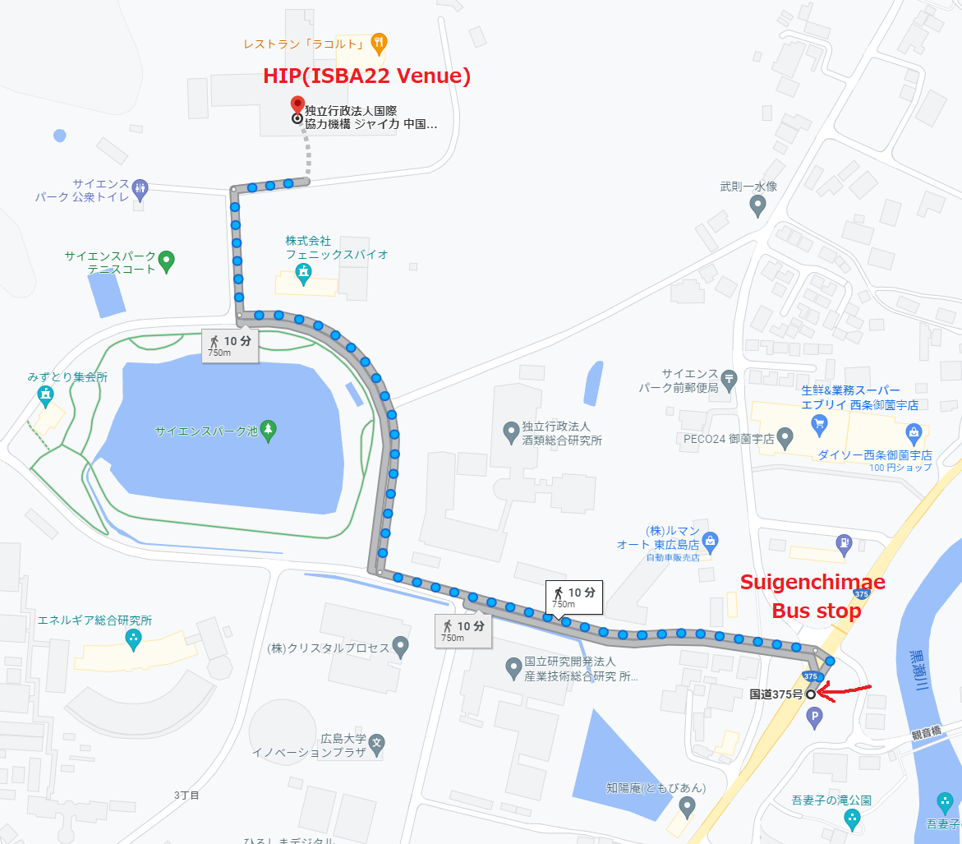

2) Buses operated by JICA and hospital

The buses operated by JICA and a hospital are free, but they run less frequently. They depart from the bus stop No. 6 in the south bus pool of Saijo station, and stop at HIP.

